**19F- 0969**

**Suneel Pirkash**

**SE_7A**

Applied DevOps

Task 04



**Created AWS account.**

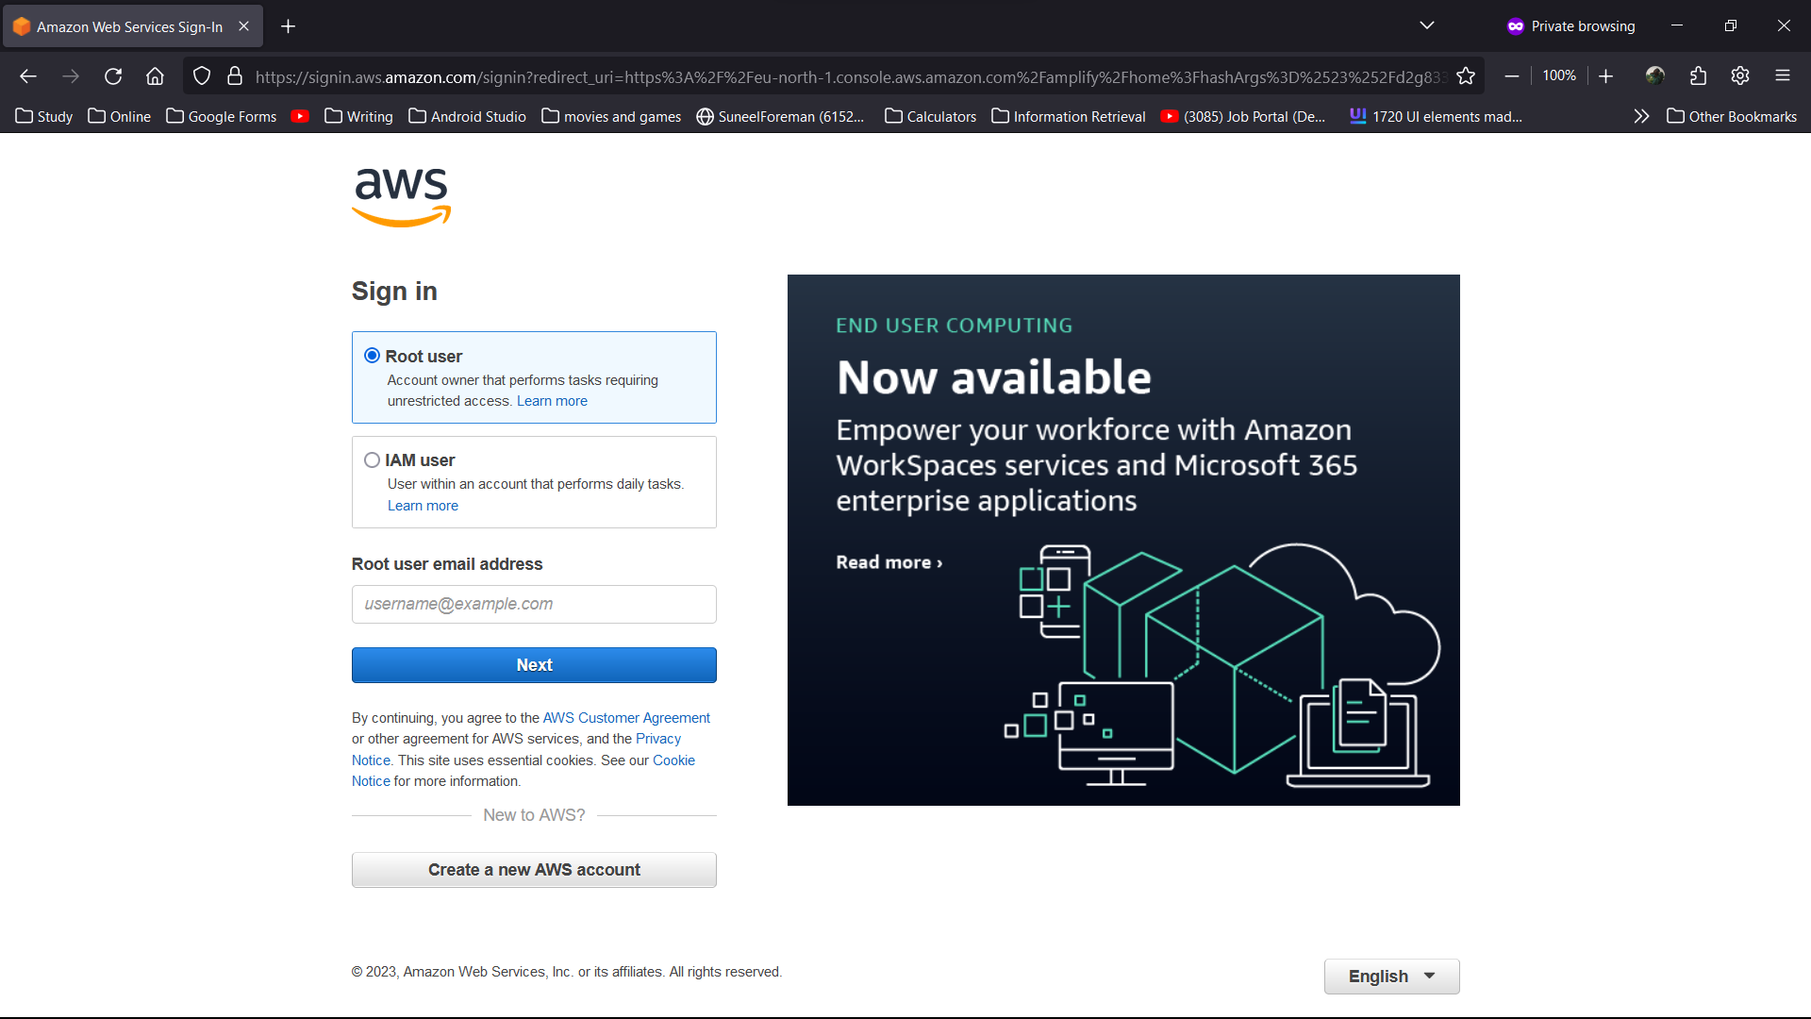

**AWS Amplify searched**

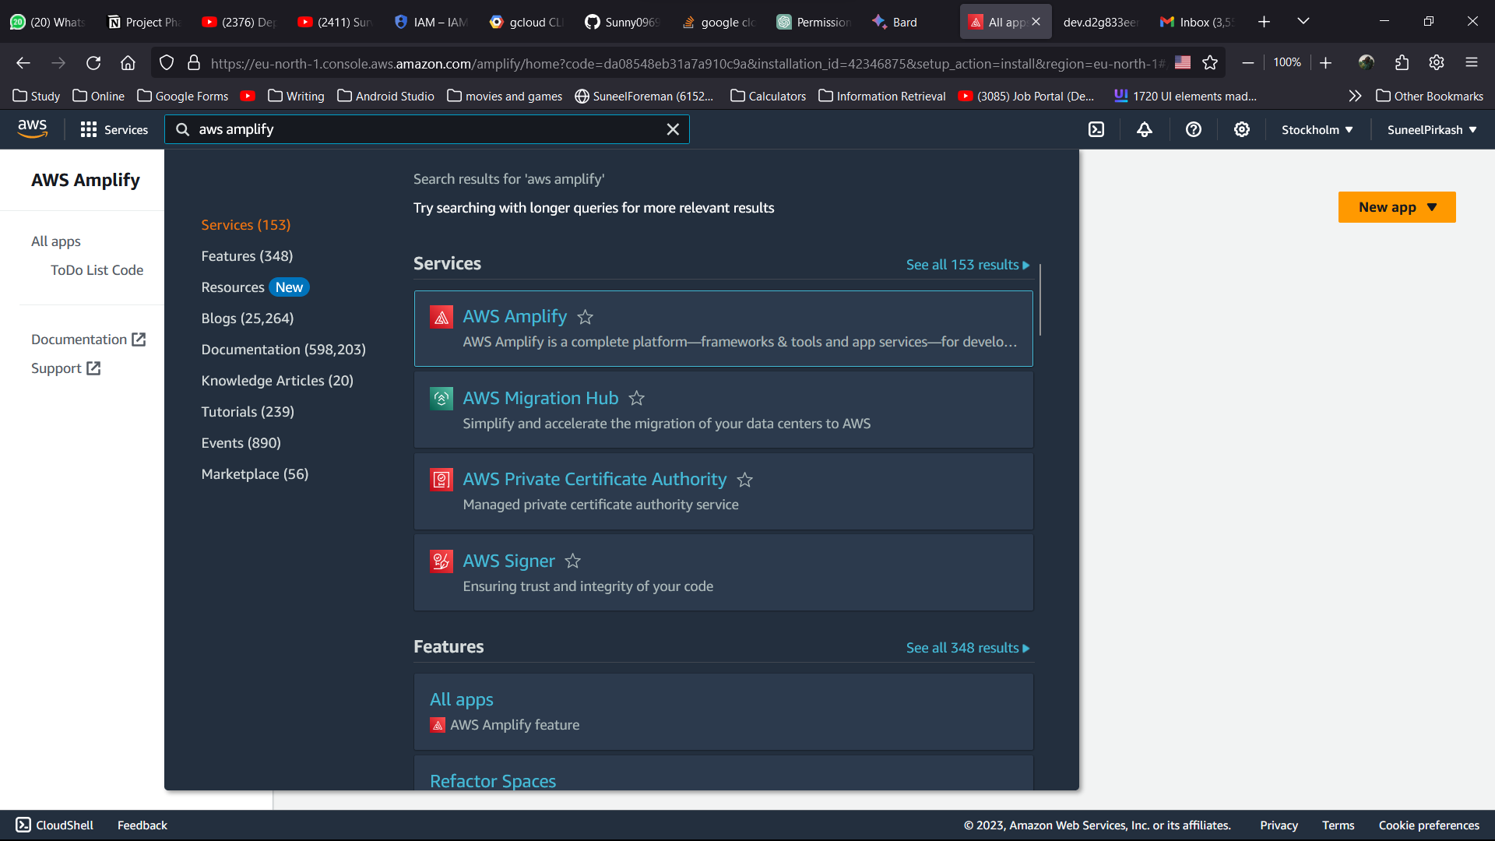

**Integrated with Github**

**Deploy project**

